Setting up the Raspberry Pi

# What you need:

1. Raspberry Pi with ethernet (Raspberry Pi 3 or 4)
2. SD card (preferably one with more than 16GB)
3. Raspberry Pi charger (micro-USB for Raspberry Pi 3, USB-C for Pi 4)
4. Ethernet Cord
5. USB-B to USB-A cord
6. Power supply with power cord
7. SD card to USB adapter (if your computer can’t read SD cards)

# Instructions

1. Download the Raspberry Pi imager on your computer from: <https://www.raspberrypi.com/software/>

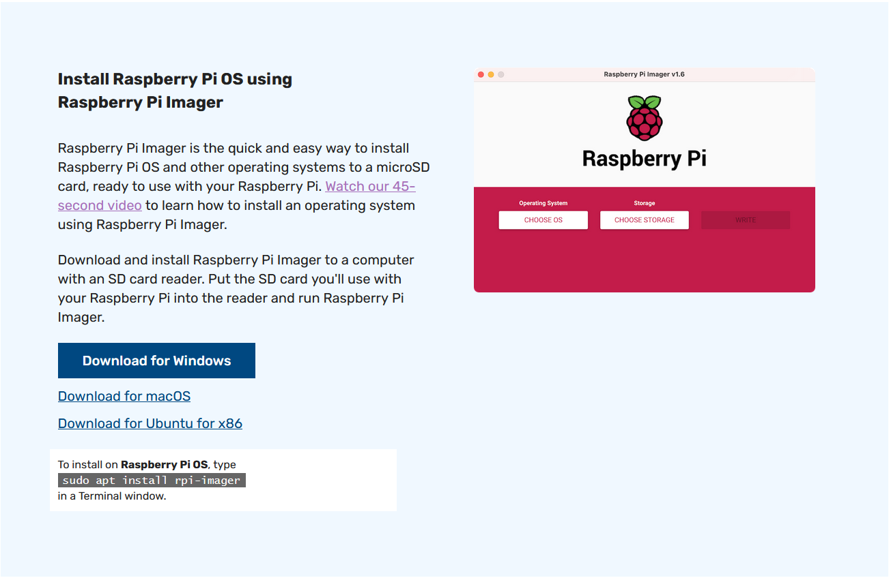

1. Plug in the SD card into your computer (might need an adapter)
2. Open the Raspberry Pi Imager
3. Choose Raspberry Pi Lite as the image and select the correct drive where the SD card is located

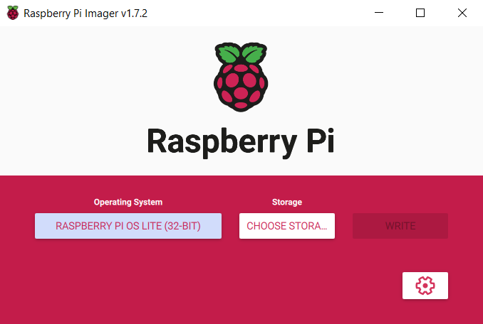

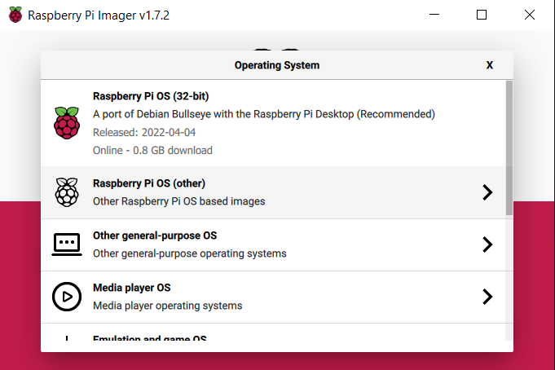

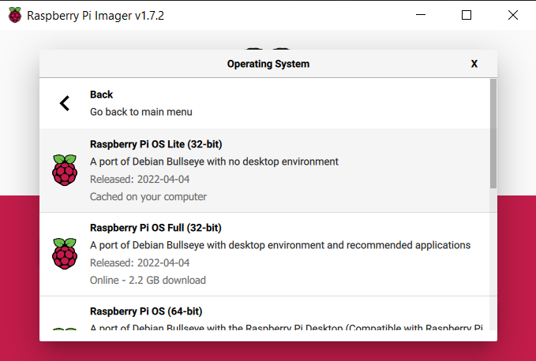

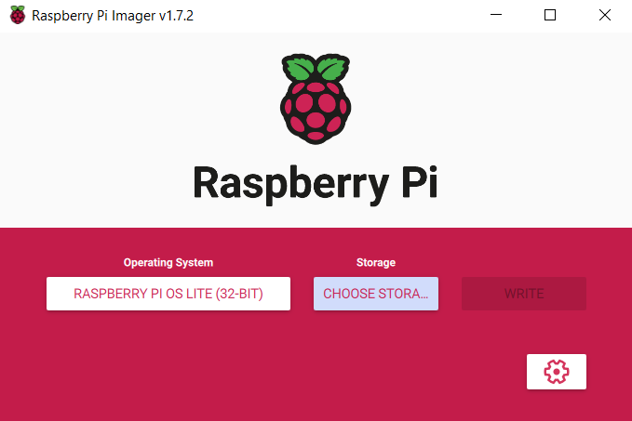

1. Configure your settings by pressing the gear button on the bottom right
   1. If you have more than one Pi on the same network is would be smart to change the hostname
   2. Enable SSH and set the username and password
   3. You can set up wifi here if you don’t want to use ethernet
   4. Set the region

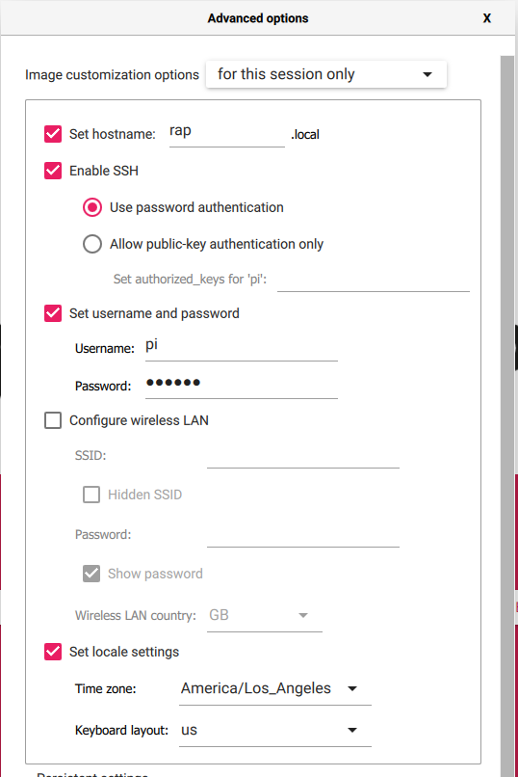

1. Write to the SD card by clicking write
2. Once it has finished writing remove the SD card and plug it into the Pi
3. Connect the Pi to ethernet and power
4. SSH into the Raspberry Pi (ensure you are on the same network):
   1. You can do so from the windows command prompt or a program of your choice
   2. I do it from VS code in all future pictures

ssh {username}@{hostname}.local

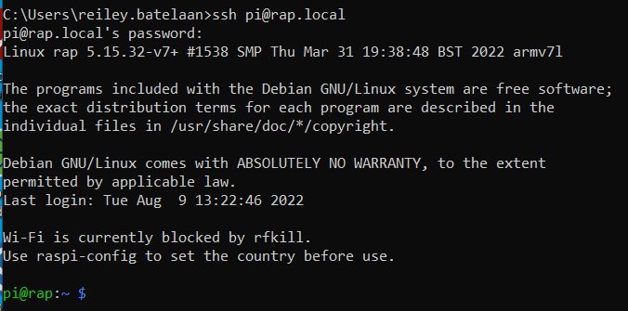

1. Update the system:

sudo apt-get update

sudo apt-get upgrade

1. If you get the following, your company might block access to NPT servers

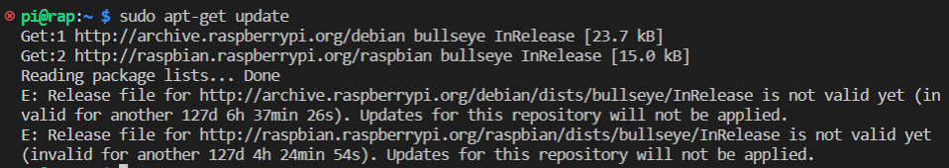

1. Update the time manually to get around this:

sudo date -s 'YYYY-MM-DD HH:MM'



1. Rerun the update commands and ensure you get no errors
2. Install pip: sudo apt-get install python3-pip

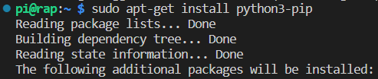

1. Install the necessary python libraries: pip3 install paho-mqtt pyvisa pyvisa-py pyusb



1. Give users access to USB devices: (still not 100% what worked)
   1. wget <https://techoverflow.net/scripts/udev-install-usbusers.sh> | sudo bash -s $USER
   2. sudo nano /etc/udev/rules.d/99-com.rules
   3. scroll down using arrow keys to the bottom of all the subsystem commands
   4. add the line: SUBSYSTEM=="usb", GROUP="usbusers", MODE="0666"

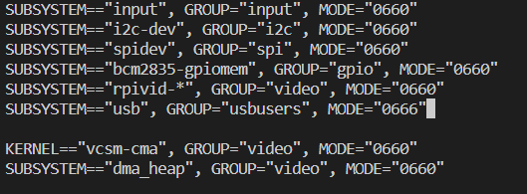

* 1. exit the file by pressing ctrl x, y, enter
  2. reboot the system: sudo reboot

1. SSH back into the Pi when it powers back on
2. Download the code: <https://AVEVA-VSTS@dev.azure.com/AVEVA-VSTS/System%20Test/_git/RigolMQTT>
   1. I think this should work (have not tested it yet as code isn’t there yet)
3. Try running the test.py file to see if USB access was setup correctly: python3 /home/{username}/test.py



* 1. Or wherever you have the files stored
  2. Make sure all instruments you have attached to the pi are discoverable (make sure they are turned on)

1. Set the script to run at startup
   1. Edit the .bashrc file: sudo nano /home/pi/.bashrc
   2. Add the following line to the end of the script:

echo Running at boot

python3 /home/{username}/connectMQTT.py |& sudo tee /home/{username}/log.txt

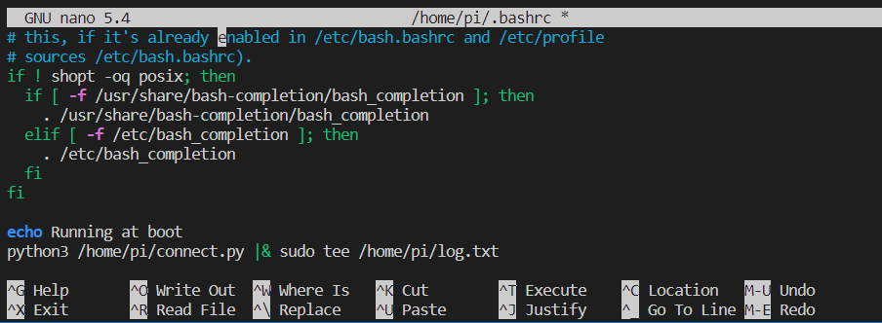

* 1. Exit the file by pressing ctrl x, y, enter

1. If there are no errors test to see if it runs at startup: sudo reboot
   1. Wait like 2 minutes for Raspberry Pi to startup